**Project Design Phase-II**

**Data Flow Diagram & User Stories**

|  |  |
| --- | --- |
| Date | 01 Nov 2023 |
| Team ID | **NM2023TMID04457** |
| Project Name | **Building a website using canva** |

**Data Flow Diagrams:**

A Data Flow Diagram (DFD) is a traditional visual representation of the information flows within a system. A neat and clear DFD can depict the right amount of the system requirement graphically. It shows how data enters and leaves the system, what changes the information, and where data is stored.

**Data Flow diagram:**

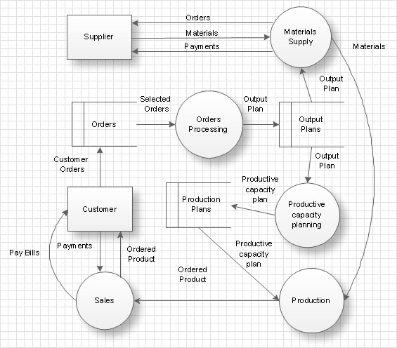

**User Stories:**

|  |  |  |  |  |  |  |
| --- | --- | --- | --- | --- | --- | --- |
| **User Type** | **Functional**  **Requirement**  **(Epic)** | **User Story Number** | **User Story / Task** | **Acceptance criteria** | **Priority** | **Team Member** |
| Customer  (Mobile user) | Online Registration | USN-1 | As a customer, I want to reserve a table online to ensure I have a spot at the cafe. | I can access the reservation system from the website.  I can select the date, time, and specify the number of guests.  I receive a confirmation email after making a reservation. | High | Yuvasri |
| Visitor | Menu Information | USN-2 | As a visitor, I want to view the cafe's menu online to plan my visit. | The website has a dedicated menu section.  I can view food and beverage listings with names, descriptions, and prices.  The menu items are categorized (e.g., breakfast, lunch, beverages). | Medium | Varsha Devi |
| Event Enthusiast | Event Information | USN-3 | As an event enthusiast, I want to access details about upcoming cafe events. | The website features an events page with event titles, dates, times, and descriptions.  Information about authors or speakers associated with events is provided. | Medium | Vimal Priya |
| Administrator | Content Management System (CMS) | USN-4 | As an administrator, I want to easily update and add content to the website without technical expertise. | A user-friendly CMS is integrated into the website.  I can edit and add content (text and visuals) without technical assistance. | High | Nandhini |
| Marketing Team | Web application | USN-5 | As a member of the marketing team, I want to implement on-page SEO practices to improve the website's visibility. | SEO best practices, including meta tags and descriptions, are applied to key pages.  The website's content is optimized for search engine ranking. | Medium | Yuvasri |